The WEEElieBin Solution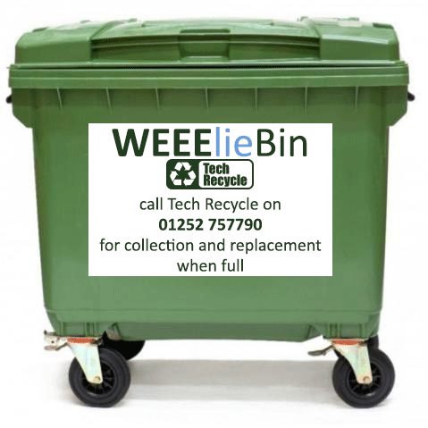
Our WEEElieBins are a tidy, convenient, safe and eco-friendly on-site solution that makes recycling waste electrical items easy and ensures that businesses are compliant with current WEEE legislation.
Simply put, it's a waterproof lockable container placed on your premises that you fill with waste electrical and electronic items for recycling and recovery.
Suitable for indoor or outdoor use, our WEEElieBins offer the complete solution for businesses in need of a simple way to dispose of their electrical and electronic waste.
Computers, Laptops, TFT monitors, cables, accessories: If it's electrical and fits in the WEEElieBin then put it in! *

We also ensure full data destruction of sensitive equipment including computer hard drives, servers, data tapes etc.

How the WEEElieBin Works

Using our WEEElieBin service couldn't be easier. All you have to do is simply follow these steps:
- Phone 01252 757790 to order your WEEElieBin.
- Your WEEElieBin is delivered straight to your premises.
- Fill your WEEElieBin with waste electrical and electronic items.
- When it’s full, call us to arrange collection.
- We’ll collect your WEEElieBin and provide a replacement.
- We'll provide a waste transfer note.

What can I put in the bin?

*You can fill the WEEElieBin with any electrical items with the exception of fluorescent tubes, light bulbs, CRT Monitors/TVs, fridges and whiteboards. Items such as Flat screen TV's are subject to our usual conditions and charges.

Please avoid packaging such as cardboard boxes, polystyrene, plastic bags etc. – this enables you to fit more in your WEEElieBin.

What does it cost?

There is a one off payment to have your first There is a one off payment to have your first WEEElieBin delivered, after that we will collect and replace the WEEElieBin whenever it is full with no extra charges*
*If the collection does not contain 10 qualifying items it will be subject to our standard charge.
If your WEEElieBin is damaged and requires replacement you will be charged £230 + VAT.
If your WEEElieBin is contaminated with non electrical items or items we can't accept there will be a cleaning charge of £85 + VAT.

WEEElieBin details and cost:

1100L – £230 + VAT (130cm high – 137cm wide – 112cm deep)

To order your wheelie bin please complete the following form and return it to
collection@tech-recycle.com

Full Name:

Company Name:

Email address:

Telephone number:

Company address:

Signature*:
*I confirm I am authorised to act on behalf of the company, I accept the terms of the service and would like to place an order.
Position:

Please return this form to collection@tech-recycle.com

